MAXX ASG FLYBARLESS SETUP MANUAL Ver1.0b

- Hooking up your flybarless unit

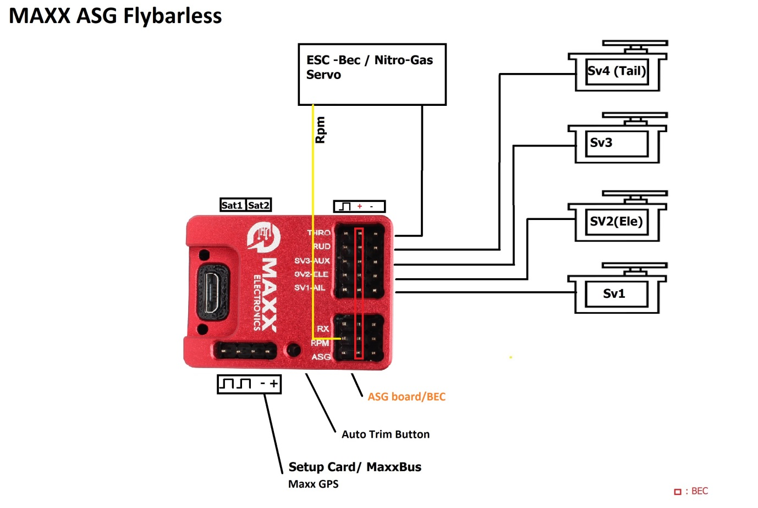
S-BUS/JR-Xbus/ UDI/ SRXL/ SRXL2/ SPM4649T/ ExBus receivers, connect to “RX” port.
Please use 2 wire BEC for size from 500 and bigger. One of two port can supply through RX, ASG or RM port or your Rx.

Please read:

Follow the diagram above when making connections to the Maxx Flybarless unit. Only make connections when prompted throughout this setup. We are first going to go through the setup your transmitter before making any connections to the unit.

Do not skip any steps!!

Warning: Prior to connecting servos to the Flybarless unit, ensure the correct servo working frequency is selected in the ‘servos’ and ‘tail’ portion of the setup. If you are unsure of the values, please refer to the factory specifications of your servos. Incorrectly selected frequency values may cause damage to your servos.

- Setting up your Transmitter (Tx):

It is important to setup your transmitter correctly before connecting the flybarless unit to the computer. Set the following parameters in your transmitter before proceeding to the next step.

- Aircraft type: Select the aircraft type in the transmitter to ‘Helicopter’

Spektrum DX/NX
System setup → model type → Helicopter

Other brands – Refer to user manual

- Swashplate type configuration – Set the correct swash type in the transmitter so it will output a signal the Flybarless is prepared to read.

Spektrum DX/NX
System setup → Swashplate type → Normal

Other brands - H1- 90degrees one servo.

- Servo parameters:

Set the following servo parameters below for all channels:

Double rates – Default, typically 100%
Travel limits / Endpoints – Default, typically +/- 100
Subtrim – Default, typically 0
Reverse – Default

Important: Never change DR (double rates) and subtrims from their default values.

- Gear/Gyro channel –

Enable the Gear channel (channel 5) to allow for transmitter-controlled tail gain adjustment. We recommend to set the tail gain to values of 30%-40% for the maiden flight.

Spektrum DX/NX setup
Pos 1 : -30% (the negative value will be used to enable rescue, more information will be given further into the setup)
Pos 2 : 30%
Pos 3 : 40%
Chan: Gear
Switch – E (Recommended)

Other brands – Refer to user manual

- Nitro only - Enable ‘Aux2’ channel to enable bank switching. A minimum of a 7-channel radio is required for this step.

Spektrum DX/NX users
System setup → Channel assign → Next → 7 Aux2 → Switch G (recommended)

Other brands – Refer to user manual

- Telemetry (only for Spektrum SRXL2 Receiver).
Need to enbable ESC and userDef1 on Telemetry menu on the transmitter.

JETI Transmitter order channel: ExBus
Throttle = 1 channel
Aileron = 2 channel
Elevator = 3 channel
Rudder = 5 channel
Gyro sens = 6 channel
Pitch = 4 channel
Aux 2= 7 channel

III. Software and setup
- Installation of software.
- Click the link below and download the .exe file. Follow the prompts to complete setup of the MAXX software. https://www.dropbox.com/sh/izwwns958gl4wet/AABqmdu25UTddCcQ4pLKcrNDa?dl=0

b. Setting up the Maxx unit:

IMPORTANT: REMOVE MAIN AND TAIL BLADES FROM HELICOPTER BEFORE STARTING.

We are now ready to start to hook up the unit.

- Connect the following items to the unit using the diagram on the first page as a reference
  - Electronics speed controller (ESC)
  - Battery elimination circuit (BEC) or 2s LiPo
  - Receiver(s) to the unit
    - Satellites: Connect to SAT1/SAT2 ports on flybarless unit. Minimum 1 satellite needs to be connected for unit to work however two satellites is recommended for optimal signal strength.

Note: If using 1 satellite, connect to SAT1.

    - JR-Xbus/ UDI/ SRXL/ ExBus (HS) receivers, connect to ‘Sbus’ port
- Connect the Maxx unit to your computer via a microUSB cable. Please ensure the cable used is high quality and in working condition. If connection is unsuccessful, please try a different cable before contacting us.
- Power on your transmitter first, and then your helicopter. Powering the unit is required when connecting to the computer.

Launch the Maxx software – It is time to setup the Maxx flybarless unit on your computer. Please read the instructions carefully, follow the tabs from
left → right, and do not skip any steps.

- START table:
      - Software - Download the Maxx flybarless user manual and carefully read the transmitter setup instructions before proceeding.

      - Connections - Make sure your receivers, ESC/Throttle servo, and BEC/2S lipo are now connected to the unit using the diagram shown on the first page of the user manual. Do not connect any servos at this step to prevent potential damage to the hardware.

      - Flying style - Select the flight style that best suits your skill level. Beginner mode will make the helicopter feel more like a co-axial model, where as hard 3D will have more of a robotic feel to the cyclic.

      - Heli size - Select the size of the helicopter you will be using with this flybarless unit. Selecting the right size will tune some hidden parameters and will help further optimize the unit to your model.

      - LowBec – Set the minimum voltage threshold in order for the unit to initialize. If using a 2S lipo without bec, set this parameter to 7.4V. If the input voltage is below the set threshold value, the unit will not complete the initialization process and will not work, this is to prevent accidentally plugging in battery that has a low charge, or faulty BEC.

      - Rescue – To enable the rescue feature, please select ON in the “Start: table on Maxx softawre. When activated during flight, the helicopter will automatically go into an upright position and apply some positive pitch. It automatically turns off after 3 seconds.

How to activate:

Rescue is activated by switching your tail gain channel (ch.5 of your transmitter) from a positive value, to a negative value.
(ex. 40% → -40%). We have already set these values into our transmitter in the previous step.

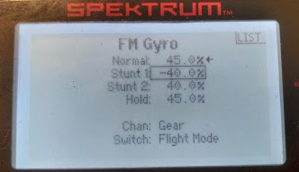
Stunt 1 is Resuce flight mode (negative value).

Channel monitor shows value less than 1520us.

The heading-hold parameter of the tail is not affected by this change in gain value. The tail respone same 40%.

On some transmitters, the tail gain value will be shown as ‘normal’ (not AVCS) when it goes below the center channel 1520us value. In any case, for the rescue to activate, the value needs to be lower than the default setting (usually 0%).

‘Rescue pitch’ – The value input here will control the amount of positive pitch the unit will apply when rescue is activated. Typical values will range from 60%-80%.

- RX/TX table:

Power on helicopter with both sticks centered on your radio and follow the steps below.

- Select your Receiver type from the drop down. If you are using Spektrum satellites, please then choose DSMX or DSM2 from the second drop down. Once you have selected your receiver type, binding your radio will be a three step process
      - Click the “Bind” button in the software
      - Briefly unplug the battery and plug It back in, your satellites should be in bind mode now. (Ex. Spektrum will show a fast blink)
      - Switch your transmitter into bind mode
        - For Spektrum DX/NX. System setup → Bind → BIND. Maxx supports 11ms and 22ms.

Your bind process is now complete.

- Signal Monitor - Verify that the movement direction of Collective pitch, rudder, aileron and elevator from the transmitter matches that of the monitors in the Maxx. If any movement is backwards, (ex. Left on aileron translates to right on the Maxx monitor), go into your transmitter servo settings, and reverse the channel(s).

Set Center - Once you have correct movement for all channels, re-center both transmitter gimbals, and hit “Set Center”. The point values when centered will range from -3 to 3 points.

Travel values (Maxx monitor) – The values on the Maxx monitors should be between 390-425 on maximum stick deflection in all directions.

Warning: Do not adjust trim adjustments on the radio and ensure they are all set to 0. Any radio trim adjustment will cause the helicopter to drift, or yaw without physical input.

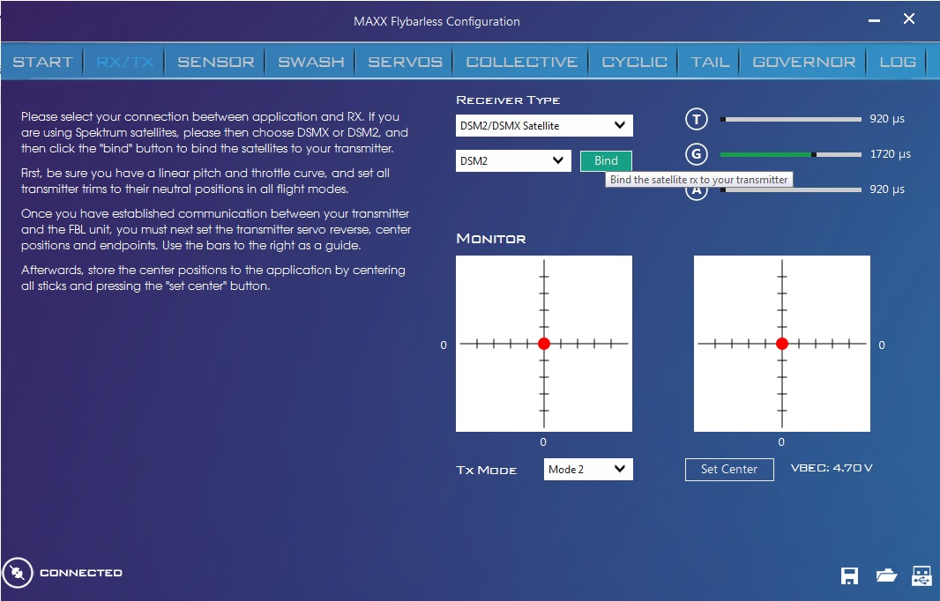
See the direction movement of virtual Tx

Note: (T) sliderbar show throttle channel value by Tx, (G) is Gear (tail gain) channel value, (A) is AUX2 (channel 7) value for switch banks by Tx, see current bank triggered by Tx in "Bank" listbox below.
If you use Maxx Electric Governor: you can switch the bank by throttle channel on Tx with 3 flats throttle curve levels about 50%, 75% and 100% for Bank1, Bank2 and Bank3.

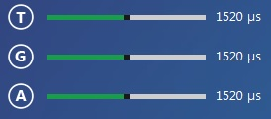
T: Monitor value of Throttle channel (low value at low throttle level is correct)
G: Monitor value of gear (tail gyro gain) channel
A: Monitor value of Aux 2 (CH7) channel

- SENSOR table:

In this step we will communicate to the flybarless unit the position of your sensor relative to your helicopter. Selecting the wrong position will be detected by the unit, and will activate a fail-safe. It is critical to make sure the correct position is selected.

Follow these two steps complete this setup

- Mount the flybarless unit on your helicopter

- Enter the correct position of the Flybarless unit based on the reference images shown.

- SWASH table:

In this step we will communicate to the flybarless unit the type of swashplate design that is on your helicopter. You must choose the correct type, otherwise all your control responses will be incorrect.

- Identify and select the swash type that matches your helicopter, pay attention to the ‘forward direction’ arrow when looking at the graphics.

- Connect the cyclic servos to the unit in the order shown.

Note: Ch 1, the Ail (Aileron) servo, is always linked to the ball on the left side of the swashplate. Ch 2, is always the Ele (elevator) servo.

- Select the correct rotational direction of your main rotor. Choosing the wrong rotation will cause the tail performance to become unpredictable.

- Expert Menu – Click the arrow on the top right hand corner to access the expert menu. For most setups, the expert menu is not needed. Use with caution.

- SERVO table:

In this step we are going to ensure correct cyclic servo setup. If you have not connected your servos, go back to the “SWASH” tab.

Note: Do not make any adjustments in your transmitter for this step.

      - Working frequency – Click the arrow in the top right to get into the expert menu, and select the frequency of the cyclic servos you will be using. If you are unsure of this value, please check with your servo manufacturer specifications
      - Swash movement - With servo’s connected, deflect your collective stick all the way up and down on your transmitter. When properly set, all servos should be, in uniform, moving the swashplate in the direction you are deflecting your stick. If there is incorrect movement, reverse the servo(s) in the software until correct movement is achieved.

Reminder: Do not reverse channels in your transmitter at this stage

      - Center servo horns - Center your Collective stick (50%), and ensure your servo horns are exactly perpendicular to your helicopter. You may use trims in the software to achieve this result by entering a value or clicking the scroll bars.

On your maiden flight:

After you have done your best to level the swash and center the horns, it recommended to run the automated swashplate trim feature. This a Maxx-only feature that that automatically makes micro-corrections to ensure your helicopter has optimal swashplate balance. Its no secret that a perfectly calibrated swashplate will give you the best possible flight performance. This is to be done on your maiden flight.

How-to use the auto-swashplate trim feature.

            - Power on both your transmitter, and helicopter. Wait for gyro to initialize.
            - Push the ‘Hole button’ on the Flybarless unit located beside the R/G/P port. You will require a very thin screwdriver or allen key to push this button. You will know it is activated when one cyclic servo makes a movement.
            - Place the helicopter into a stable hover at a distance and height you are comfortable with.
            - Deflect your stick to any one side and continuously piro for 10s at a high rate.
            - Land the helicopter, and push the ‘Hole button’ once more to save your new swash trim values.

- COLLECTIVE table:

In this step, you will set setup your collective direction, and collective travel, or in other words, your pitch limits.

Collective direction – Identify your collective direction by looking at the reference photos. Pay attention to how the blade grip arms are positioned relative to the pitch links.

Travel (+/-) – Sets your maximum / minimum pitch. Use a pitch gauge to set your desired maximum pitch travel (typically +/-12-14 degrees). Software values should fall between 45 and 60. If desired pitch is not achieved within the recommended values, you may adjust the travel/end points of your Pitch channel in your transmitter from default (normally 100 points). Do not go lower than 80 points or higher than 120 points on your transmitter, doing so will prevent the flybarless unit from reading the signal correctly.

Pitch pump (expert menu) – Adjusting this value will increase or decrease your collective response when making fast movements with your collective stick. This helps with performing maneuvers that require fast changes in collective such as tic-tocs, a higher value will make your changes in pitch a lot sharper. Recommended value is 50 for first flight.

Collective trim – This setting allows you trim your collective center. With correct mechanical setup, and properly adjusted servo trims in the previous step, modification to this value (0) should not be required. If making changes, please recheck your max/min pitch travel.

- CYCLIC table:

In this step we will adjust the flight characteristics of your cyclic movements. Please read the following instructions before making changes.

Limit: This setting will set the maximum throw for your cyclic inputs. Use a pitch gauge and place the collective stick in the center (pitch gauge should read 0 deg.) and fully deflect the aileron stick to the left or right. Adjust the values so that at full aileron deflection, the pitch reads 11-12 degrees. Values exceeding 120 is an indication that the servo arms are too short. Values below 85 indicate that the servo arms are too long.

Agility – This setting adjusts the response of your helicopter. Increasing this value will make your helicopter more responsive. Higher values will aid in maneuvers like tic-tocs, but too much can reduce smoothness of maneuvers like piro-flips. It is recommended to use the default value for your maiden flight, and adjust as needed to suit your flying style.

Gain: This setting adjusts the sensitivity of the cyclic gyro sensor. Values that are too high may create oscillation in the head. Values that are too low will reduce the feeling of a ‘locked in’ helicopter. For the maiden flight, use the default value of 60, and if needed, make small adjustments until you achieve the desired result.
-Advanced menu: The default P-I-D gain settings are 50-0-50.
Proportional gain (P-gain) – Increasing this parameter will adjust the speed of response to inputs. Too high of a value may provoke oscillation or wobbling of the main rotor.
Integral Gain (I-Gain) – Higher values will increase main rotor holding power in its position. Adjusting this setting is recommended only for scale-helicopters.
D – Increasing D gain will help stabilize cyclic hard stops. You may need to increase this value if running extreme RPM’s. (ex. 2250+ on 700 size heli). A value that is too high may cause fast oscillation in the head during stops.

Roll rate and Flip rate: This setting allows you to adjust the roll rate and flip rate of your heli. The values represent degrees per second therefore a value of 360, at full stick deflection, will roll/flip the helicopter one full rotation per second. Equal flip/roll values of 250 is recommended for beginners, 270-280 for light 3D, and 300 for extreme 3D.

RC Deadband: This settings allows you to adjust the ‘dead space’ around center stick. Increasing this value will allow for larger movements from center stick without input to the heli. Your heli will be more forgiving to unwanted stick movements. Decreasing this value will make it more sensitive, registering even the smallest movements on the stick. Recommended values range from 4-12. Note
Note: This will not affect your collective response.

Paddle simulator: This setting allows to simulate the heavy, smooth feel of a flybar helicopter. Increase this value for a smoother feel, decrease the value for a more robotic feel.

Elevatator precomp (Eleprecom) – This setting allows you to adjust the response of your elevator. Increasing this value will make your elevator more agile.

Note: Click the default button to return all value to the recommended value for the first flight

- TAIL table:

In this step we will be connecting your tail and setting up its parameters. Read the instructions and only plug in the tail servo when prompted.

Servo type: Please select the correct center pulse and/or its associated frequency. If you are unsure of its value, please check the factory specifications of your tail servo. Selecting the wrong setting may damage your tail servo and prevent the rescue from functioning correctly.

Connection: Once your frequency is selected, turn off your heli and it is now time to connect your tail servo.

Servo Reversal –Move the tail servo with your rudder stick, and ensure the direction is correct. Click on the Servo graphic to reverse the servo direction if needed.
Note: Do not do any reversals in your transmitter at this stage.

Trim – This setting is used to trim the servo horn center position. On most helicopters this is perpendicular to your tail push rod. If required, enter positive or negative values to achieve the desired result.

Travel CW/CCW (R/L) : This setting allows you to adjust your maximum travel for your tail servo. A tail that is correctly set will have 0 degrees pitch at center, and will have full travel to both directions on the tail shaft. When adjusting, make sure there is no servo binding at full deflection of the rudder stick.

Expert page:

Tail rotor
- Yaw Rate – This settings allows to adjust the speed of tail rotation. The value represents degrees per second.
- Gain – Your tail gain is adjusted by the Gear channel (Ch.5) on your transmitter. The scroll bar displays the value that is set on your transmitter. Higher gain will result in a better holding tail with snappy tail stops. A value that is too high will cause oscillation. A value that is too low will cause for a sloppy tail with soft stops. Make small adjustments up or down on your transmitter to achieve the desired result. Suggested gain values will range from 30-50% for 3D flight. Lower headspeed will require a higher, more sensitive tail gain. Higher headpeed will require a lower, less sensitive tail gain.
Note: Negative tail gain values will activate rescue.

Acceleration Parameter – Increasing this value will

Tail stop L: This setting allows you to fine adjust the tail behavior when stopping. Increasing this value will make for a snappier stopping power. Decreasing this value will create softer stopping.

Tail Stop R – This setting allows you to adjust the acceleration and tail stop, together in one direction. Increasing this value will increase sensitivity in the CW direction. Decreasing, will increase sentivity in the CCW direction.

Precomp – This setting adjusts the amount of pre-compensation of tail when applying cyclic, or collective pitch. If you find that the tail drifts when applying a lot of collective pitch, increase this value to compensate for the torque.

P-I-D Tail gain – Note that it is not recommended to change these values unless you are well experienced.

Proportional Gain (P-Gain) –
Expert version to the ‘simple gain’ setting explained earlier, this setting will stabilize your tail. A value that is too high will cause oscillation, or a slow wag. Too low of a value will result in a sloppy tail.

Integral gain (I-Gain) –
This setting should only be changed for scale-heli flying. This has the effect of…

Derivative Gain (D-Gain) –
Expert version to the ‘tail stop. This setting sets the holding sensitivity on hard stops. A value that is too high will cause oscillation. Too low of a value will result in a sloppy tail.

Note: Click the default button to return all value to the recommended value for the first flight

Governor Table:

In this step, we will be setting up the Maxx Governor. If you planning to use your ESC governor, please skip this step. If no governor is set up at all, your throttle will be entirely dependant on your throttle curve values in your transmitter.

Before starting: Ensure the throttle channel is not reversed by checking the “T” Throttle channel values the Maxx monitors (RX/TX tab). Reverse the channel on your transmitter if needed to get the correct motion.

Note for nitro: If the Throttle signal is showing correct motion on the Maxx monitor, but the throttle servo is reversed, reverse the throttle servo in the software by checking the “Reverse throttle servo” box in the Governor Tab.

ESC calibration: Disable your ESC governor by setting it to External Governor mode, or Airplane mode. Read your ESC Manual to confirm the correct setting for a disabled governor.

      - Turn off ESC’s governor, throttle travel calibration – We need to make sure the Maxx unit sees the full throttle signal spectrum. Turn off your heli until prompted.

        - Set a linear throttle curve (0-100) in your transmitter
        - With the linear curve selected, throw your throttle stick to 100% (all the way up) and power on your heli
        - Wait until the red LED shows quick flashing on the Maxx unit. (If nitro, wait until the throttle servo goes into fully open position.) Within 3 seconds, push the throttle stick all the way down (0%). The Maxx unit will now automatically saved the throttle end-points.
Note: If the Throttle signal is showing correct on the Maxx monitor, but the throttle servo is reversed, reverse the throttle servo in the Maxx software.
        - Ensure the throttle stick motion is synchronized with the “T” values shown on the on the Maxx software monitors (TX/RX tab). Throttle stick all the way down should have the slider all the way to the left, while the stick all the way up, should have the slider all the way to the right, showing a full green bar.
Note: On some ESCs, you will need to set the throttle endpoints on the ESC before performing the steps above. Go over your ESC manual to check this.

To setup the MAXX Governor

Transmitter setup:

For electric helicopters:

      - Set three flat throttle curves in your transmitter.
        - 50%
        - 75%
        - 100%

For Nitro helicopters
      - Set a single throttle curve of 100-60-100. The nitro governor uses AUX2 (Channel 7) for bank switching between flight modes, we will set this up later.
Note: The Governor activates when the throttle input value is above 30%

Connect the throttle to ‘thro’ on the Flybarless unit, and the RPM signal wire to ‘rpm/ele’. The RPM signal wire normally has a connector with one lead.
Note: It is not recommended to physically place the RPM signal wire near the 3 phase wires to reduce signal noise.

Ensure your Throttle channel (T) and AUX2 (A) are showing the correct values on the Maxx monitor (RX/TX tab). Check for travel direction, and reverse the channel(s) in your transmitter if necessary.

In the Governor Tab, switch the governor drop down from Disabled to Electric or Nitro depending on your model.

Setting up

If using Electric
            - Input your three desired headspeed values. RPM1 will be activated with your 50% throttle flight mode, RPM2 with your 75% flight mode, and RPM3 with your 100% flight mode
            - Enter your gear ratio, if you are not sure of this value, check your helicopter manual.
            - Enter the motor Pole count, check your motor specs if unsure.

Note: Please consult a headspeed calculator to ensure the desired headspeeds are within the range of your motor efficiency (85%).

If using Nitro

            - Input your three desired headspeed values.
            - Enter your gear ratio, if you are not sure of this value, check your helicopter manual.
            - Check your RPM sensor by turning your main rotor by hand. Once the magnet approaches the sensor ,you will see a single green blink on the Maxx unit, you should see one green blink for each rotation.

Note: It is not recommended to place the RPM signal wire near the 3 phase wires to reduce signal noise.

StartThro: This setting allows you to control the amount of throttle the unit will output to the ESC when throttle hold is turned off, before soft start is initiated.
Recommended value: 5%

Scrollup: This Setting allows you to control the speed at which the heli will spool up between the StartThro value and your desired headspeed. For faster spool up, increase this value.
Recommended value: 2.

Autorotatio Bailout: This function helps to quickly scrollup RPM when you want to exit autorotation mode.
Installation steps:
- Turn on Maxx Governor.
- Set throttle level on hold mode to 15%
- Set Aux2 channel (channel 7) on transimitter to center value or higher to trigger this funcition. Only for Nitro/Gasser heli, electric heli doesn't need this.
- Selected checkbox to turn on this function.

Note: Governor MUST be turned ON for the soft start to be activated. There will be no soft-start feature when the governor is turned off.

Bank Table

In this step, we will be setting up the parameters of your three banks. This allows you to set three different flying styles, using different values for each bank.

Electric Helicopters with Maxx Governor enbabled:
Banks on electric helicopters get switched when switching between flight modes. Bank1 settings get used when using RPM1. Bank 2 settings get used with RPM2, etc.

Nitro Helicopters or Maxx Governor turned off:
Banks on electric helicopters get switched when switching between flight modes with your AUX2 switch. Bank1 settings get used when using RPM1. Bank 2 settings get used with RPM2, etc.

Switch setup:

Spektrum DX/NX users: Functions list → Governor → Switch G (recommended) → Chan: AUX2

Set your three way AUX2 switch to have the following values:

Position 1: 50%
Position 2: 75%
Position 3: 100%

Note: After setting up the three positions, go back to the Maxx monitors on the TX/RX tab and ensure that the values shown for AUX2 “A” show 1520us when at position 1 (50%) , 1720us at position 2 (75%), and 1920us at Position 3 (100%)

- LOG table

In this tab you may check your flight logs. We will add more information on this later.

Maiden flight

Congratulations, you have successfully setup your Maxx flybarless unit and it is now ready to fly. Power on your helicopter and wait for each servo to make an independent movement. You are now ready to fly.

Program card

If you have purchased the program card, you may change any of these settings at any time without having to hook up the Maxx unit to a computer. It makes it very easy to make adjustment at the field.

IV. Firmware upgrade

- Download the MAXX FW (firmware).
  - Download and put firmware file (.dfu file) to any folder on your PC.
  - Install Dfu upgrade tool in folder you have downloaded by right click and choose “Run as Administrator”

- Install Driver for Dfu upgrade tools (Only for Windows 10 if Dfu driver problem):
+ Go Win10 Directory for all OS installed in your machine at C:\Program Files (x86)\MAXX Flybarless\DfuSe v3.0.6\Bin\Driver
+ Then based on your OS version:
- Double click on dpinst_x86.exe if you are running a 32-bits OS version
- Double click on dpinst_amd64.exe if you are running a 64-bits OS version
+ Follow the instructions

3. Put Maxx units to Dfu mode
a. Plug battery to power on heli and connect with PC via USB cable.
b. Run Maxx software. Once ‘connected’ is seen on the bottom left, and click the USB icon in the far right hand corner of the Maxx software (next to the folder icon). Click ‘Update Firmware,’ the MAxx software will automatically close, the Dfu upgrade tool will be started automatically.
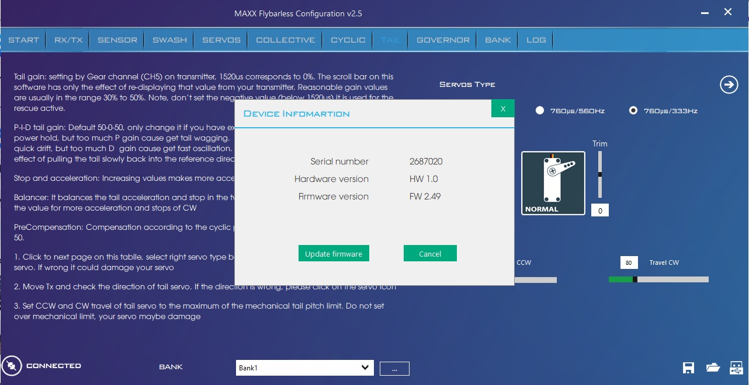
Once the Maxx units red LED starts to fast blink, the unit is in DFU mode and is now ready to be updated.

4. Upgrade from Dfu mode

If unsure, please check the photo below for refence.

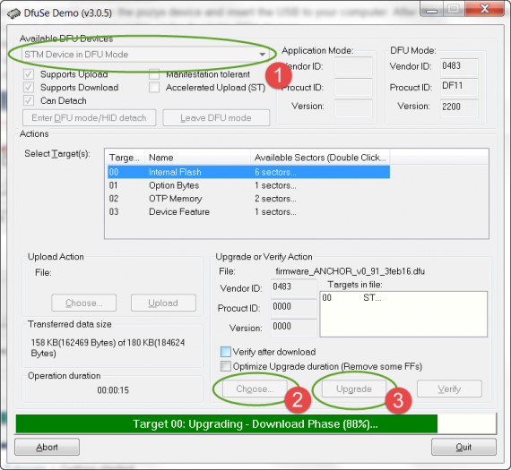
- for see Maxx device detected only, no action required

- Select the firmware file you have downloaded to your computer and click the Upgrade button on the Dfu tool (button 3 above).
- Waiting to copmplated and unplug battery and re-plug again.

